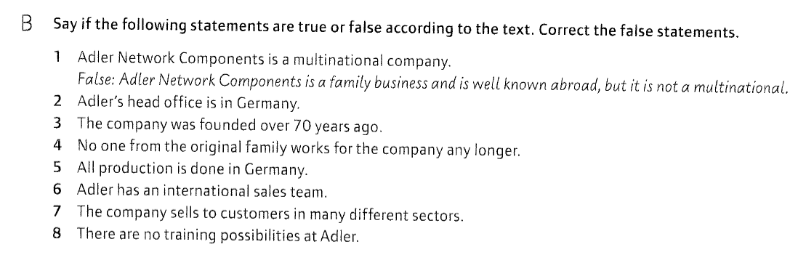

2) true

3)true

4)Adler Network Components is still a family business.

5)There are 11 factories, located in Germany, the Netherlands, France, Great Britain, Romania, the USA and China.

6) true

7)true

8)Voacational training and apprenticeships for young people play a central role in the company.

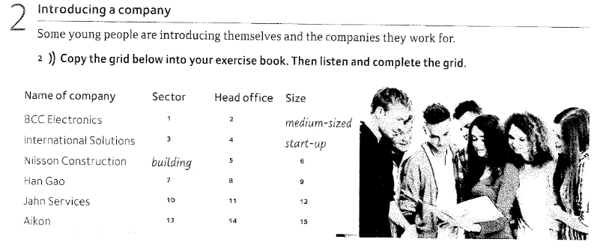

|  |  |  |  |
| --- | --- | --- | --- |
|  | Sector | Head Office | Size |
| bbc | Electronic equiment | London | Medium sized |
| International Solutions | IT-Company | Berlin | Start up |
| Nilsson Construction | Building company | Stockholm | big multinational |
| Han Gao | Metal dealer | Hong Kong | Global company |
| Jahn Services | automotiv | Minden | large company |
| Aikon | medical equiment | Stuttgart | Small company |

Ein Bild, das Text enthält.

Name: Deutsche Rentenversicherung Bund

Sector: pension insurance

Location: Berlin, Gera, Stralsund, Brandenburg an der Havel, Würzburg

Number of employees: 25.000

What the company does: Support to pensioners

Target group pensioners

Some competitors: Deutsche Rentenversicherung Knappschaft-Bahn-See & Regionalträger but they are not really competitors